

Capstone Project Document

**FIRST AID**

**Report #2 – Software Requirement Specification**

|  |  |  |
| --- | --- | --- |
| **First Aid** | | |
| **Group Members** | Đàm Huy Hùng | SE03431 |
| Nguyễn Duy Anh | 01525 |
| Mai Trung Kiên | SE02994 |
| Nguyễn Tiến Dũng | SE03272 |
| Nguyễn Phúc An | SE03118 |
| **Supervisor** | Mr. Nguyễn Văn Sang | |
| **Project code** | FAVN | |

**- Hanoi, 09/2016 -**

# **SIGNATURE PAGE**

AUTHOR: Nguyễn Duy Anh 00/09/2016

Team member

REVIEWERS: Đàm Huy Hùng 00/09/2016

Project Manager

APPROVAL: Nguyễn Văn Sang --/--/--16

Supervisor

Record of change

*A - Added M - Modified D – Deleted

|  |  |  |  |  |  |
| --- | --- | --- | --- | --- | --- |
| Effective Date | Changed Item | A,M,D | Change Description | Reason for Change | Rev. Number |
| 01/10/2015 | Create Software Requirements Specifications | A | First version | Create Software Requirements Specifications | 1.0 |
| 02/10/2015 | Modify Business rule, Non-Functional specification | M | First version | Modify Software Requirements Specifications | 1.1 |
| 09/12/2015 | Modify Use case | M | First version | Modify Software Requirements Specifications | 1.2 |
|  |  |  |  |  |  |
|  |  |  |  |  |  |
|  |  |  |  |  |  |

**TABLE CONTENTS**

**SIGNATURE PAGE 2**

**1. INTRODUCTION 4**

1.1. Purpose 4

1.2. Definitions and Acronyms 4

1.3. System Purpose 5

**2.** **OVERALL DESCRIPTION 5**

2.1. System overview 5

2.2. Use Case Diagram 7

2.3. Product Features 7

2.3.1. User Characteristics 9

2.3.2. User Documentation 10

2.3.3. Assumption 10

2.4. Entity Relation Model 10

2.4.1. Entity-Relationship Diagram 10

2.4.2. Entity Detail 11

**3.** **FUNCTIONAL SPECIFICATION** 14

3.1. Business Rules 14

3.2. Use Cases 16

3.2.1. Guest/ Registered Group Function 16

3.2.2. Guest Group Function 36

3.2.3. Registered Group Function 38

3.2.4. Administrator Group Function 54

**4.** **NON-FUNCTIONAL SPECIFICATION** 96

4.1. Reliability 96

4.2. Performance Requirements 96

4.2.1. Availability 96

4.2.2. Response time 96

4.2.3. Maintainability 96

4.2.4. Usability 97

4.2.5. Security Requirements 97

4.2.6. Hardware/Software Requirements 97

# **INTRODUCTION**

## **Purpose**

This document is created as the introduction for project First Aid – our Capstone Project at FPT University. In this document, we provide the describing of general requirement and non-functional requirements. These requirements will ensure that the system will correctly and reliably perform its intended functionality. This specification will provide general, as well as specific requirements to be used in the design, testing and validation of the system. It is intended for both stakeholders and the project team of the system.

## **Definitions and Acronyms**

|  |  |  |
| --- | --- | --- |
| **Acronym** | **Definition** | **Note** |
| FAA | First Aid application |  |
| SRS | Software Requirements Specifications |  |
| Admin | FA’s administrator |  |
| Customer | FA’s user |  |

Table 2-1: Definition and Acronyms

## **System Purpose**

For the purpose of offering Vietnamese people effective methods in emergencies, as well as help the community better understand what is aid and the importance of first aid, we implement a project to develop an application that can be like an assistance for users, called First Aid. In First Aid application, we can solve the limitations of hard copy documents and other products. Besides, we provide first aid’s step-by-step instructions to make sure that even untrained people can understand and follow. In addition, users can make SOS calling and find nearby hospitals and other useful features for life saving.

# **OVERALL DESCRIPTION**

## **System overview**

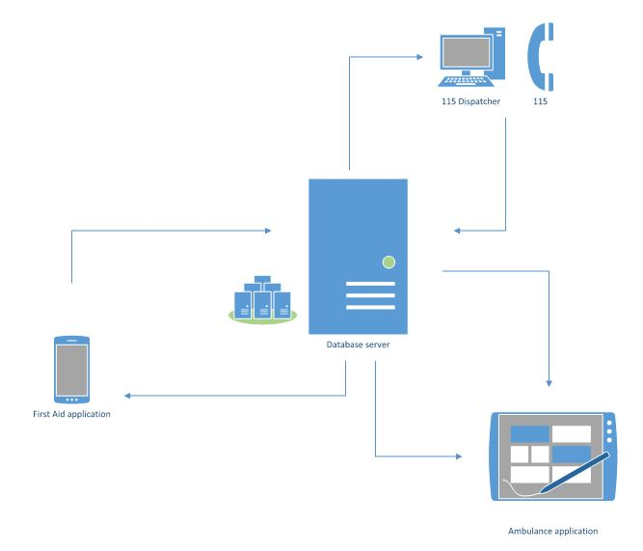

Figure 2-1: System Overview

## **Product Features**

|  |  |  |  |
| --- | --- | --- | --- |
| UC No. | Group Of Functions | Function | Glossary |
| First Aid Application | | | |
|  | Emergencies | View emergency list |  |
|  | View first aid of an emergency |  |
|  | Search emergencies |  |
|  | Call 115 |  |
|  | Speak first aid |  |
|  | View current location |  |
|  | View nearest hospital list |  |
|  | Direct to hospital |  |
|  | Call to hospital |  |
|  | Learning | View learning list |  |
|  | View learning detail |  |
|  | View FAQs |  |
|  | More | Sent question |  |
|  | View notification |  |
|  | View first aid course |  |
|  | Share application |  |
|  | Setting | Notify about update |  |
|  | Send information |  |
|  | Info | View application information |  |

Table 2-2-1: List of use case

|  |  |  |  |  |
| --- | --- | --- | --- | --- |
| UC No. | Group Of Functions | Function | Glossary | |
| Dispatcher | | | | |
|  | Common | Login | |  |
|  | Logout | |  |
|  | Emergency | Create emergency case | |  |
|  | Dispatch an ambulance | |  |
|  | View ambulance info, status, location, view caller | |  |
|  | View direction from ambulance to caller | |  |
|  | View in process list of cases are pending ambulance | |  |
|  | Delete item in process | |  |

Table 2-2-2: List of use case

|  |  |  |  |  |  |
| --- | --- | --- | --- | --- | --- |
| UC No. | Group Of Functions | | Function | Glossary | |
| Ambulance Application | | | | | |
|  | Common | Login | | |  |
|  | Logout | | |  |
|  | Emergency | View status ambulance team | | |  |
|  | Notify task | | |  |
|  | View the location of caller | | |  |
|  | Direct to the location of caller | | |  |
|  | Report picked up caller | | |  |
|  | Report completed task | | |  |
|  | Cancel task | | |  |
|  | View task history | | |  |

Table 2-2-3: List of use case

|  |  |  |  |  |  |
| --- | --- | --- | --- | --- | --- |
| UC No. | Group Of Functions | | Function | | Glossary |
| Administration | | | | | |
| Admin | | | | | |
|  | Common | Admin login | |  | |
|  | Admin logout | |  | |
|  | Manage user's account | Create account | |  | |
|  | View list user | |  | |
|  | View user profile | |  | |
|  | Search user's account | |  | |
|  | Deactivate user’s account | |  | |
|  | Delete user’s account | |  | |
|  | Reset user’s password | |  | |
|  | Manage first aid | Add new first aid | |  | |
|  | Search first aid | |  | |
|  | Update first aid | |  | |
|  | Delete first aid | |  | |
|  | Add new lecture | |  | |
|  | Search lecture | |  | |
|  | Update lecture | |  | |
|  | Delete lecture | |  | |
|  | Manage Q&A | View user’s comments | |  | |
|  | View user’s question | |  | |
|  | View expert’s answer | |  | |
|  | Statistic FAQs | |  | |
|  | View FAQs | |  | |
| Expert | | | | | |
|  | Common | Login | |  | |
|  | Logout | |  | |
|  | Edit information | |  | |
|  | Manage Q&A | View user’s question | |  | |
|  | Answer the question | |  | |

Table 2-2-4: List of use case

## **User Characteristics**

DDL website towards to anyone wants to launch a project on Dandelion as long as it follows our rules. Project creators set a funding goal and deadline. If people like a project, they can pledge money to make it happen. Backers are supporting projects to help them come to life, not to profit financially. Instead, project creators offer rewards to thank backers for their support. DDL has three objective users:

* **Guest:** Users did not register, they can use some function like Register, Discover project, Search, etc...
* Registered: Users have account on DDL, they can use almost functions of DDL for user like Login, Logout, Create, Manage project, Comment, Report, etc…
* **Administrator:** They can use all functions of normal member and have an Administrator control panel to manage all information, project and configuration of DDL.

## **User Documentation**

|  |  |
| --- | --- |
| Name | Description |
| User Guide | Provide detailed explanation about the system, screens and guide users how to use all features of DDL. |

Table 2-3: User Documentation

## **Assumption**

* Receive the guidance and good support of teacher.
* No one of member got sick in the software development process.
* In the development process, no device got fail.
* Every report, task meets the deadline.
* Team member do not conflict in the work process.

## **Entity Relation Model**

### **Entity-Relationship Diagram**

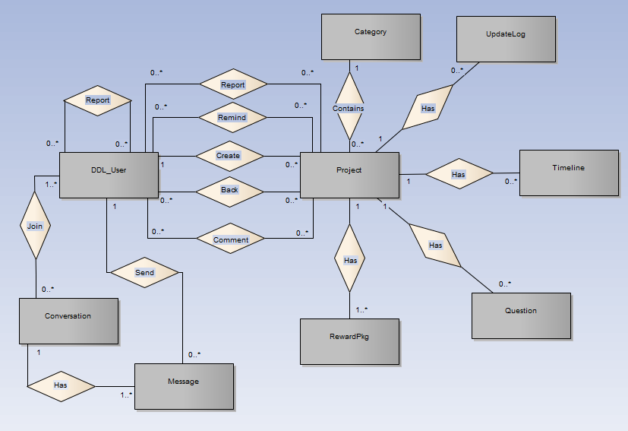

**Figure 2-3:** Entity Relationship Diagram

### **Entity Detail**

#### DDL_User

|  |  |  |  |  |
| --- | --- | --- | --- | --- |
| No | Attribute | Type | Mandatory | Description |
|  | UserID | Int | Y | User’s ID |
|  | UserName | String | Y | User’s name |
|  | Password | String | Y | User’s password |
|  | IsActive | Boolean | Y | User’s active status (inactive, active) |
|  | CreatedDate | Date | Y | User’s created date |
|  | LoginType | String | Y | User’s created type includes: normal, Facebook or both |
|  | LastLogin | Date | Y | User’s last login |
|  | UserType | String | Y | User’s type (admin or normal user) |
|  | IsVerify | Boolean | Y | User’ email verify status |
|  | VerifyCode | String | Y | User’s verify code |
|  | Email | String | Y | User’s email |

Table 2-4: DDL-User

#### Project

|  |  |  |  |  |
| --- | --- | --- | --- | --- |
| No | Attribute | Type | Mandatory | Description |
|  | ProjectID | Int | Y | Project’s ID |
|  | ProjectCode | String | Y | Project’s code with fixed format |
|  | CategoryID | Int | Y | Project’s category |
|  | UserID | Int | Y | Project’s UserID who created project |
|  | ProjectTitle | String | Y | Project’s title |
|  | Risk | String | Y | Project’s risk |
|  | ImageLink | String | Y | Project’s image link |
|  | SubDescription | String | Y | Project’s sub description |
|  | Location | String | Y | Project’s location created |
|  | IsExpired | Boolean | Y | Is Project’s expired |
|  | CurrentFunded | Decimal | Y | Project’s funded status |
|  | IsFunded | Boolean | Y | Is Project’s funded |
|  | CreatedDate | Date | Y | Project’s created date |
|  | ExpiredDate | Date | Y | Project’s expired date |
|  | FundingGoal | Decimal | Y | Project’s funding goal |
|  | Description | String | Y | Project’s description |
|  | LinkVideo | String | Y | Project’s video link |
|  | Story | String | Y | Project’s story |
|  | PopularPoint | Int | Y | Project’s popular point |
|  | Status | String | Y | Project’s status ( draft, pending, approved, suspended) |
|  | UpdatedDate | Date |  | Project’s updatedDate |

Table 2-5: Project

#### Category

|  |  |  |  |  |
| --- | --- | --- | --- | --- |
| No | Attribute | Type | Mandatory | Description |
| 1. 1 | CategoryID | Int | Y | Category’s ID |
| 1. 2 | Name | String | Y | Category’s name |
| 1. 3 | IsActive | Boolean | Y | Category’s active status |
|  | Description | String | Y | Category’s description |

Table 2-6: Category

#### UpdateLog table

|  |  |  |  |  |
| --- | --- | --- | --- | --- |
| No | Attribute | Type | Mandatory | Description |
| 1. 1 | UpdateID | Int | Y | Update’s ID |
| 1. 2 | ProjectID | Int | Y | Update’s project id |
| 1. 3 | Title | String | Y | Update’s title |
|  | Description | String | Y | Update’s description |
|  | CreatedDate | Date | Y | Update’s createdDate |

Table 2-7: UpdateLog table

#### Timeline table

|  |  |  |  |  |
| --- | --- | --- | --- | --- |
| No | Attribute | Type | Mandatory | Description |
| 1. 1 | TimelineID | Int | Y | Timeline’s ID |
| 1. 2 | ProjectID | Int | Y | Timeline’s project id |
| 1. 3 | Title | String | Y | Timeline’s title |
|  | Description | String | Y | Timeline’s description |
|  | DueDate | Date | Y | Timeline’s due date |
|  | ImageUrl | String | Y | Timeline’s Image Url |

Table 2-8: Timeline table

#### Question table

|  |  |  |  |  |
| --- | --- | --- | --- | --- |
| No | Attribute | Type | Mandatory | Description |
| 1. 1 | QuestionID | Number | Y | Question and answer’s ID |
| 1. 2 | ProjectID | Number | Y | Question and answer’s project id |
| 1. 3 | Question | String | Y | Question and answer’s question |
|  | Answer | String | Y | Question and answer’s answer |
|  | CreatedDate | Date | Y | Question and answer’s created date |

Table 2-9: Caption table

#### Reward package table

|  |  |  |  |  |
| --- | --- | --- | --- | --- |
| No | Attribute | Type | Mandatory | Description |
| 1. 1 | RewardID | Int | Y | Reward’s ID |
| 1. 2 | ProjectID | Int | Y | Reward’s project id |
| 1. 3 | LimitedQuantity | String | Y | Reward’s limited quantity |
|  | Type | String | Y | Reward’s type |
|  | Description | String | Y | Reward’s description |
|  | EstimatedDeliveryDate | Date | Y | Reward’s estimated delivery date |
|  | IsHide | Boolean | Y | Is Reward hide |
|  | CurrentQuantity | int | Y | Reward’s current quantity |
|  | PledgeAmount | Decimal | Y | Reward’s PledgeAmount |

Table 2-10: Reward package table

#### Message table

|  |  |  |  |  |
| --- | --- | --- | --- | --- |
| No | Attribute | Type | Mandatory | Description |
| 1. 1 | MessageID | Number | Y | Message’s ID |
| 1. 2 | ConversationID | Number | Y | Message’s conversation id |
| 1. 3 | UserID | Number | Y | Message’s user id |
|  | MessageContent | String | Y | Message’s content |
|  | SentTime | Date | Y | Message’s sent time |

Table 2-11: Message table

#### Conversation table

|  |  |  |  |  |
| --- | --- | --- | --- | --- |
| No | Attribute | Type | Mandatory | Description |
|  | ConversationID | Number | Y | Conversation’s ID |
|  | CreatorID | Number | Y | Conversation’s creator id |
|  | ReceiverID | Number | Y | Conversation’s receiver |
|  | Subject | String | Y | Conversation’s subject |
|  | CreatedDate | Date | Y | Conversation’s created date |
|  | UpdatedDate | Date | Y | Conversation’s update date |
|  | DeleteStatus | String | Y | Conversation’s user delete status |
|  | ViewStatus | String | Y | Conversation’s user view status |

Table 2-12: Conversation table

# **FUNCTIONAL SPECIFICATION**

## **Business Rules**

|  |  |
| --- | --- |
| **No** | **Description** |
|  | Search textbox cannot be empty |
|  | Content is limited to 1000 characters |
|  | Chat box cannot be empty |
|  | Subject is limited to 1000 characters |
|  | Name cannot be empty |
|  | If user accesses to nonexistent page, DDL displays error message “Page not found” |
|  | Email must content characters ‘@’ and ‘.’ |
|  | Date of birth must be chosen |
|  | Displayed date is mm/dd/yyyy format |
|  | Date time input format is datetime |
|  | Number is rounded to 2 decimal number |
|  | Unit of money is VND |
|  | Displayed money is rounded to 2 decimal number |
|  | Allowed file extension: .jpg, .png, .bmp |
|  | File size is limited to 100 MB |
|  | Guest could back project without login |
|  | Message displayed like a Gmail format |
|  | Rank is calculated depending on funding of the project |

Table 2-13: Business rules

## **Use Cases**

### **First Aid Application Function**

#### Emergencies Module

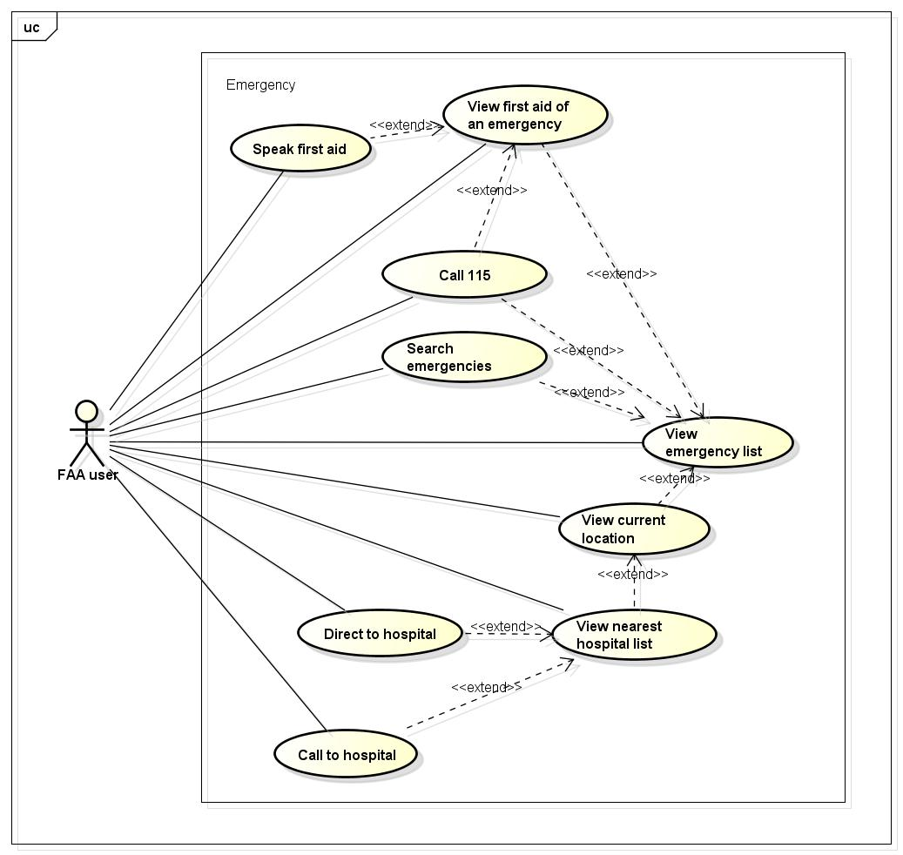

Figure 1-4: Emergencies use case

##### UC001 - View emergency list

|  |  |  |  |  |
| --- | --- | --- | --- | --- |
| **Use Case ID** | | UC001 | **Version** | 1.1 |
| **Use Case Name** | | View emergency list | | |
| **Created by:** | | AnhND | **Date Created:** | 24/09/2016 |
| **Primary Actor** | | Customer | **Secondary Actor** |  |
| **Description:** | | This function allows customer to view all emergencies need to first aid in First Aid application. | | |
| **Preconditions:** | | Install First Aid application | | |
| **Trigger:** | | Customer launch application | | |
| **Post conditions:** | | All existing emergencies will be displayed in the mobile screen. | | |
| **Normal Flow** | | | | |
| **Step** | **Actor** | **Action** | | |
| 1 | Customer | Launch application | | |
| 2 | FAA | List all existing emergencies | | |
| **Alternative Flows: N/A** | | | | |
| **Exceptions: N/A** | | | | |
| **Priority** | | High | | |
| **Frequency of Use:** | | High | | |
| **Business Rules:** | |  | | |
| **Other Information:** | | N/A | | |

Table 2- 14: View emergency list

##### UC002 - View first aid of an emergency

|  |  |  |  |  |
| --- | --- | --- | --- | --- |
| **Use Case ID** | | UC002 | **Version** | 1.1 |
| **Use Case Name** | | View first aid of an emergency | | |
| **Created by:** | | AnhND | **Date Created:** | 24/09/2016 |
| **Primary Actor** | | Customer | **Secondary Actor** |  |
| **Description:** | | This function allows customer to view first aid step instructions of an emergency. | | |
| **Preconditions:** | | 1. Install First Aid application 2. Customer launch application | | |
| **Trigger:** | | Customer taps on an emergency in the list emergencies that displayed in the mobile screen. | | |
| **Post conditions:** | | All first aid step instructions about this emergency will be displayed in the mobile screen. | | |
| **Normal Flow** | | | | |
| **Step** | **Actor** | **Action** | | |
| 1 | Customer | Launch application | | |
| 2 | Customer | Tap on an emergency in the list | | |
| 3 | FAA | Show all first aid step instructions | | |
| **Alternative Flows:** | | | | |
| **AT1** | At step 2 in the main flows, if customer taps on other buttons. | | | |
| **Step** | **Actor** | **Action** | | |
| 2.1 | FAA | Redirects customer to chosen button. | | |
| **Exceptions: N/A** | | | | |
| **Priority** | | High | | |
| **Frequency of Use:** | | High | | |
| **Business Rules:** | |  | | |
| **Other Information:** | | N/A | | |

Table 2- 14: View first aid of an emergency

##### UC003 - Search emergencies

|  |  |  |  |  |
| --- | --- | --- | --- | --- |
| **Use Case ID** | | UC003 | **Version** | 1.1 |
| **Use Case Name** | | Search emergencies | | |
| **Created by:** | | AnhND | **Date Created:** | 24/09/2016 |
| **Primary Actor** | | Customer | **Secondary Actor** |  |
| **Description:** | | This function allows customer to search an emergency exits on FAA by text | | |
| **Preconditions:** | | 1. Install First Aid application 2. Customer launch application | | |
| **Trigger:** | | Customer taps on search button, enters search phrase and taps Search | | |
| **Post conditions:** | | All results that matched with the keyword customer enters will be displayed in the mobile screen | | |
| **Normal Flow** | | | | |
| **Step** | **Actor** | **Action** | | |
| 1 | Customer | Tap on search button | | |
| 2 | Customer | Enter search phrase to text box | | |
| 3 | Customer | Tap Search | | |
| 4 | DDL | List all results that matched with the keyword customer entered | | |
| **Alternative Flows:** | | | | |
| **AT1** | At step 2 in the main flows, if customer taps on an emergency in the list under the text box. | | | |
| **Step** | **Actor** | **Action** | | |
| 2.1 | FAA | Redirects customer to first aid step instructions of chosen emergency. | | |
|  | | | | |
| **AT2** | At step 2 in the main flows, if customer taps on back button. | | | |
| **Step** | **Actor** | **Action** | | |
| 2.1 | FAA | Redirects customer to emergencies screen | | |
|  | | | | |
| **AT3** | At step 3 in the main flows, if customer taps on [x] button | | | |
| **Step** | **Actor** | **Action** | | |
| 3.1 | FAA | Redirects customer to text box to enters search phrase | | |
| **Exceptions: N/A** | | | | |
| **Priority** | | High | | |
| **Frequency of Use:** | | High | | |
| **Business Rules:** | |  | | |
| **Other Information:** | | N/A | | |

Table 2- 15: Search emergencies

##### UC004 - Call 115

|  |  |  |  |  |
| --- | --- | --- | --- | --- |
| **Use Case ID** | | UC004 | **Version** | 1.1 |
| **Use Case Name** | | Call 115 | | |
| **Created by:** | | AnhND | **Date Created:** | 24/09/2016 |
| **Primary Actor** | | Customer | **Secondary Actor** |  |
| **Description:** | | This function allows customer to make emergency calls to the 115 center. | | |
| **Preconditions:** | | 1. Install First Aid application 2. Customer launch application | | |
| **Trigger:** | |  | | |
| **Post conditions:** | |  | | |
| **Normal Flow** | | | | |
| **Step** | **Actor** | **Action** | | |
| 1 | Customer | Launch application | | |
| 2 | Customer |  | | |
| 3 | FAA |  | | |
| **Alternative Flows:** | | | | |
| **AT1** |  | | | |
| **Step** | **Actor** | **Action** | | |
|  |  |  | | |
| **Exceptions: N/A** | | | | |
| **Priority** | | High | | |
| **Frequency of Use:** | | High | | |
| **Business Rules:** | |  | | |
| **Other Information:** | | N/A | | |

Table 2- 15: Call 115

##### UC005 - Speak first aid

|  |  |  |  |  |
| --- | --- | --- | --- | --- |
| **Use Case ID** | | UC005 | **Version** | 1.1 |
| **Use Case Name** | | View current location | | |
| **Created by:** | | AnhND | **Date Created:** | 24/09/2016 |
| **Primary Actor** | | Customer | **Secondary Actor** |  |
| **Description:** | | This function allows customer to locate their current location correctly. | | |
| **Preconditions:** | | 1. Install First Aid application 2. Customer launch application | | |
| **Trigger:** | |  | | |
| **Post conditions:** | |  | | |
| **Normal Flow** | | | | |
| **Step** | **Actor** | **Action** | | |
| 1 | Customer | Launch application | | |
| 2 | Customer |  | | |
| 3 | FAA |  | | |
| **Alternative Flows:** | | | | |
| **AT1** |  | | | |
| **Step** | **Actor** | **Action** | | |
|  |  |  | | |
| **Exceptions: N/A** | | | | |
| **Priority** | | High | | |
| **Frequency of Use:** | | High | | |
| **Business Rules:** | |  | | |
| **Other Information:** | | N/A | | |

Table 2- 15: View current location

##### UC006 - View current location

|  |  |  |  |  |
| --- | --- | --- | --- | --- |
| **Use Case ID** | | UC006 | **Version** | 1.1 |
| **Use Case Name** | | View current location | | |
| **Created by:** | | AnhND | **Date Created:** | 24/09/2016 |
| **Primary Actor** | | Customer | **Secondary Actor** |  |
| **Description:** | | This function allows customer to locate their current location correctly. | | |
| **Preconditions:** | | 1. Install First Aid application 2. Customer launch application | | |
| **Trigger:** | |  | | |
| **Post conditions:** | |  | | |
| **Normal Flow** | | | | |
| **Step** | **Actor** | **Action** | | |
| 1 | Customer | Launch application | | |
| 2 | Customer |  | | |
| 3 | FAA |  | | |
| **Alternative Flows:** | | | | |
| **AT1** |  | | | |
| **Step** | **Actor** | **Action** | | |
|  |  |  | | |
| **Exceptions: N/A** | | | | |
| **Priority** | | High | | |
| **Frequency of Use:** | | High | | |
| **Business Rules:** | |  | | |
| **Other Information:** | | N/A | | |

Table 2- 15: View current location

##### UC007 - View nearest hospital list

|  |  |  |  |  |
| --- | --- | --- | --- | --- |
| **Use Case ID** | | UC007 | **Version** | 1.1 |
| **Use Case Name** | | View list nearest hospitals | | |
| **Created by:** | | AnhND | **Date Created:** | 24/09/2016 |
| **Primary Actor** | | Customer | **Secondary Actor** |  |
| **Description:** | | This function allows customer to view nearest hospital list from their location. | | |
| **Preconditions:** | | 1. Install First Aid application 2. Customer launch application | | |
| **Trigger:** | |  | | |
| **Post conditions:** | |  | | |
| **Normal Flow** | | | | |
| **Step** | **Actor** | **Action** | | |
| 1 | Customer | Launch application | | |
| 2 | Customer |  | | |
| 3 | FAA |  | | |
| **Alternative Flows:** | | | | |
| **AT1** |  | | | |
| **Step** | **Actor** | **Action** | | |
|  |  |  | | |
| **Exceptions: N/A** | | | | |
| **Priority** | | High | | |
| **Frequency of Use:** | | High | | |
| **Business Rules:** | |  | | |
| **Other Information:** | | N/A | | |

Table 2- 15: View nearest hospital list

##### UC008 - Direct to hospital

|  |  |  |  |  |
| --- | --- | --- | --- | --- |
| **Use Case ID** | | UC008 | **Version** | 1.1 |
| **Use Case Name** | | Direct to hospital | | |
| **Created by:** | | AnhND | **Date Created:** | 24/09/2016 |
| **Primary Actor** | | Customer | **Secondary Actor** |  |
| **Description:** | | This function allows customer to view nearest hospital list from their location. | | |
| **Preconditions:** | | 1. Install First Aid application 2. Customer launch application | | |
| **Trigger:** | |  | | |
| **Post conditions:** | |  | | |
| **Normal Flow** | | | | |
| **Step** | **Actor** | **Action** | | |
| 1 | Customer | Launch application | | |
| 2 | Customer |  | | |
| 3 | FAA |  | | |
| **Alternative Flows:** | | | | |
| **AT1** |  | | | |
| **Step** | **Actor** | **Action** | | |
|  |  |  | | |
| **Exceptions: N/A** | | | | |
| **Priority** | | High | | |
| **Frequency of Use:** | | High | | |
| **Business Rules:** | |  | | |
| **Other Information:** | | N/A | | |

Table 2- 15: Direct to hospital

##### UC009 - Call to hospital

|  |  |  |  |  |
| --- | --- | --- | --- | --- |
| **Use Case ID** | | UC009 | **Version** | 1.1 |
| **Use Case Name** | | Call hospital | | |
| **Created by:** | | AnhND | **Date Created:** | 24/09/2016 |
| **Primary Actor** | | Customer | **Secondary Actor** |  |
| **Description:** | | This function allows customer to call to the hospital | | |
| **Preconditions:** | | 1. Install First Aid application 2. Customer launch application | | |
| **Trigger:** | |  | | |
| **Post conditions:** | |  | | |
| **Normal Flow** | | | | |
| **Step** | **Actor** | **Action** | | |
| 1 | Customer | Launch application | | |
| 2 | Customer |  | | |
| 3 | FAA |  | | |
| **Alternative Flows:** | | | | |
| **AT1** |  | | | |
| **Step** | **Actor** | **Action** | | |
|  |  |  | | |
| **Exceptions: N/A** | | | | |
| **Priority** | | High | | |
| **Frequency of Use:** | | High | | |
| **Business Rules:** | |  | | |
| **Other Information:** | | N/A | | |

Table 2- 15: Call to hospital

#### Learning Module

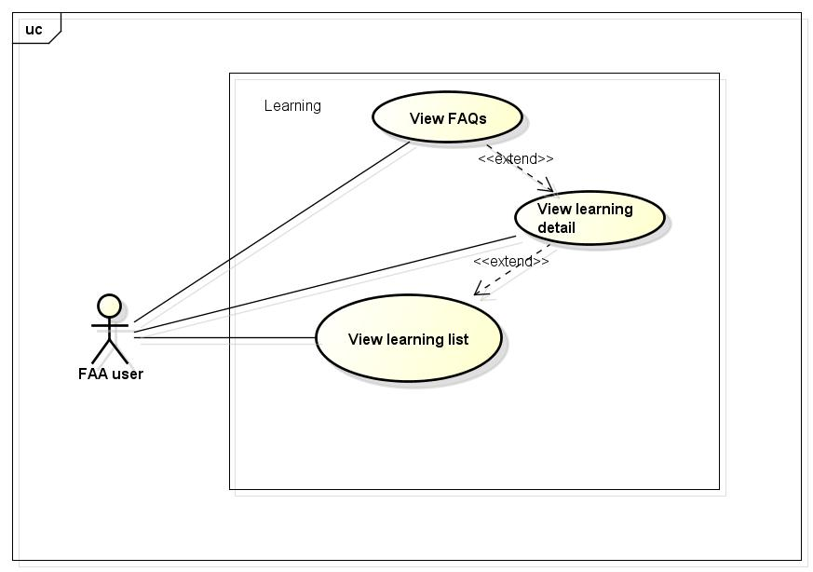

Figure 2-5: Learning use case

##### UC0010 - View learning list

|  |  |  |  |  |
| --- | --- | --- | --- | --- |
| **Use Case ID** | | UC0010 | **Version** | 1.1 |
| **Use Case Name** | | View project | | |
| **Created by:** | | MaiCTP | **Date Created:** | 24/09/2015 |
| **Primary Actor** | | Registered user  Guest | **Secondary Actor** |  |
| **Description:** | | This function allows user to view all existing information of the project(description, risks, Q&A, …) | | |
| **Preconditions:** | | 1. DDL website is available  2. User browsed DDL website | | |
| **Trigger:** | | User clicks on View Project button/ Name of the project. | | |
| **Post conditions:** | | Common information of this project is displayed | | |
| **Normal Flow** | | | | |
| **Step** | **Actor** | **Action** | | |
| 1 | User | Click on View Project button or Click on name of the project | | |
| 2 | DDL | Display View Project page includes  5 tabs:  -          Campaign  -          Update  -          Comments | | |
| **Alternative Flows:  N/A** | | | | |
| **Exceptions: N/A** | | | | |
| **Priority** | | High | | |
| **Frequency of Use:** | | High | | |
| **Business Rules:** | | B1 | | |
| **Other Information:** | | N/A | | |

View project Use case

##### UC0011 - View learning detail

|  |  |  |  |  |
| --- | --- | --- | --- | --- |
| **Use Case ID** | | UC0011 | **Version** | 1.1 |
| **Use Case Name** | | View campaign | | |
| **Created by:** | | MaiCTP | **Date Created:** | 24/09/2015 |
| **Primary Actor** | | Registered user  Guest | **Secondary Actor** |  |
| **Description:** | | This function allows user to view all common existing information of the project(description, risks, Q&A, …) | | |
| **Preconditions:** | | 1. DDL website is available  2. User browsed DDL website  3. User choose the project that user want to see | | |
| **Trigger:** | | User clicks on View Project button/ Name of the project. | | |
| **Post conditions:** | | Common information of this project is displayed | | |
| **Normal Flow** | | | | |
| **Step** | **Actor** | **Action** | | |
| 1 | User | Click on View Project button or Click on name of the project | | |
| 2 | DDL | Display View Project page includes  5 tabs:  -          Campaign  -          Update  -          Comments  With Campaign tab is default. | | |
| **Alternative Flows:  N/A** | | | | |
| **Exceptions: N/A** | | | | |
| **Priority** | | High | | |
| **Frequency of Use:** | | High | | |
| **Business Rules:** | | B1 | | |
| **Other Information:** | | N/A | | |

Table 2- 17: View campaign Use case

##### UC0012 - View FAQs

|  |  |  |  |  |
| --- | --- | --- | --- | --- |
| **Use Case ID** | | UC0012 | **Version** | 1.1 |
| **Use Case Name** | | View update | | |
| **Created by:** | | MaiCTP | **Date Created:** | 24/09/2015 |
| **Primary Actor** | | Registered user  Guest | **Secondary Actor** |  |
| **Description:** | | This function allows user to view all update existing information of the project | | |
| **Preconditions:** | | 1.       DDL website is available  2.       User browsed DDL website  3.       User choose the project that user want to see | | |
| **Trigger:** | | User clicks on Update tab | | |
| **Post conditions:** | | Update information of this project is displayed | | |
| **Normal Flow** | | | | |
| **Step** | **Actor** | **Action** | | |
| 1 | User | Click on View Project button or Click on name of the project | | |
| 2 | DDL | Display View Project page includes  5 tabs:  -          Campaign  -          Update  -          Comments  With Campaign tab is default. | | |
| 3 | User | Click on Update tab | | |
| 4 | DDL | Display Update page with all updated information. | | |
| **Alternative Flows:  N/A** | | | | |
| **Exceptions: N/A** | | | | |
| **Priority** | | High | | |
| **Frequency of Use:** | | High | | |
| **Business Rules:** | | B1 | | |
| **Other Information:** | | N/A | | |

Table 2- 18: View update Use case

#### More Module

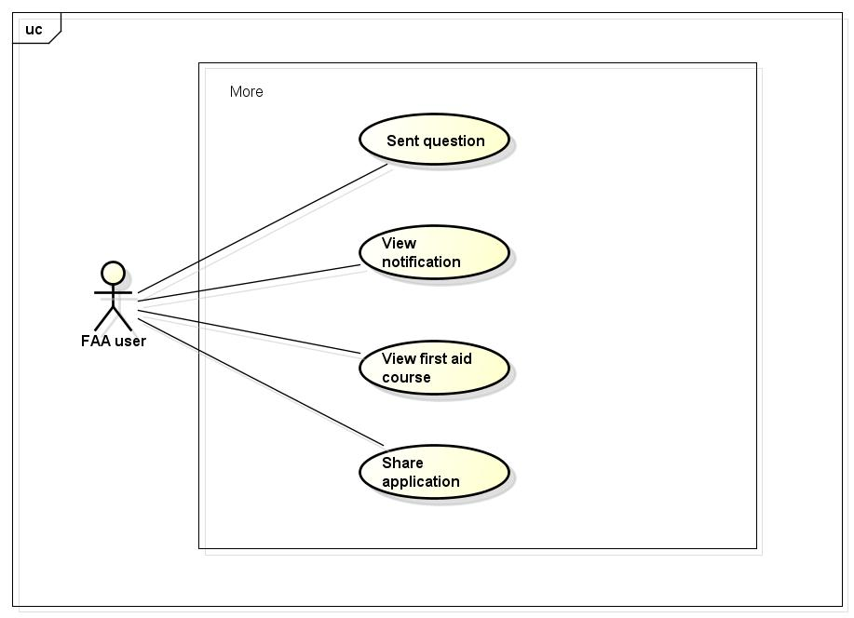

|  |  |  |  |  |
| --- | --- | --- | --- | --- |
| **Use Case ID** | | UC006 | **Version** | 1.1 |
| **Use Case Name** | | View comments | | |
| **Created by:** | | MaiCTP | **Date Created:** | 24/09/2015 |
| **Primary Actor** | | Registered user  Guest | **Secondary Actor** |  |
| **Description:** | | This function allows user to view all existing comment of the project | | |
| **Preconditions:** | | 1.       DDL website is available  2.       User browsed DDL website  3.       User choose the project that user want to see | | |
| **Trigger:** | | User clicks on Comments tab | | |
| **Post conditions:** | | All comments of this project is displayed | | |
| **Normal Flow** | | | | |
| **Step** | **Actor** | **Action** | | |
| 1 | User | Click on View Project button or Click on name of the project | | |
| 2 | DDL | Display View Project page includes  5 tabs:  -          Campaign  -          Update  -          Comments  With Campaign tab is default. | | |
| 3 | User | Click on Comments tab | | |
| 4 | DDL | Display Comments page with all messages of this project. | | |
| **Alternative Flows:  N/A** | | | | |
| **Exceptions: N/A** | | | | |
| **Priority** | | High | | |
| **Frequency of Use:** | | High | | |
| **Business Rules:** | | B1 | | |
| **Other Information:** | | N/A | | |

Table 2- 19: View comments Use case

#### Setting module

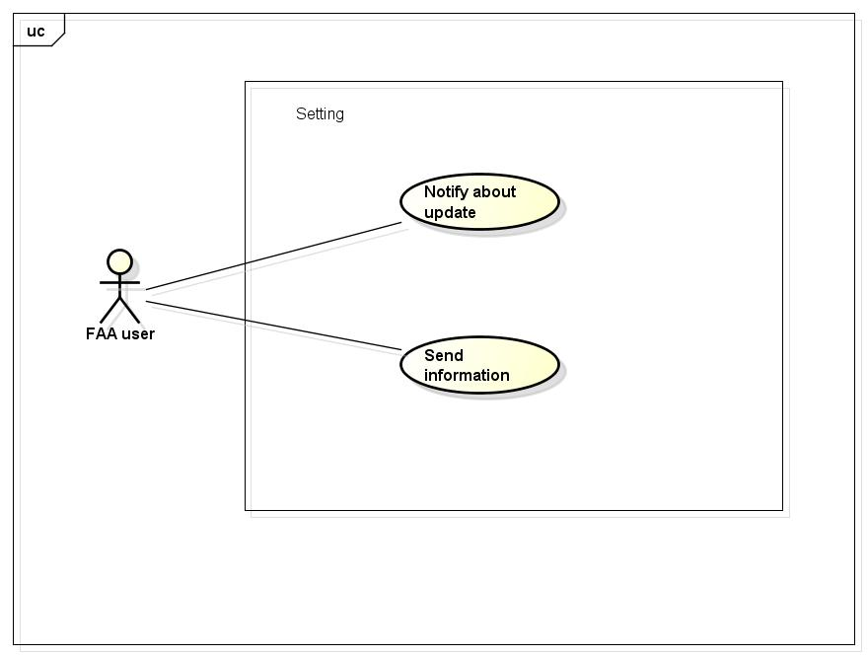

#### Info Module

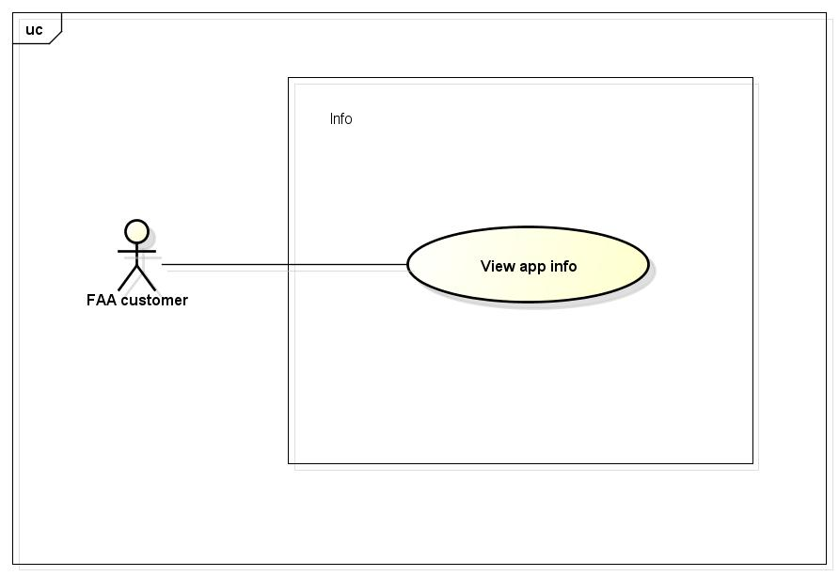

|  |  |  |  |  |  |
| --- | --- | --- | --- | --- | --- |
| **Use Case ID** | | | UC007 | **Version** | 1.1 |
| **Use Case Name** | | | Register | | |
| **Created by:** | | | AnhDD | **Date Created:** | 24/09/2015 |
| **Primary Actor** | | | Guest | **Secondary Actor** |  |
| **Description:** | | | Visitor can create new account to use more function as a register user | | |
| **Preconditions:** | | | 1. DDL must be connected to the Internet 2. User browsed DDL website | | |
| **Trigger:** | | | Click on register link on the website | | |
| **Post conditions:** | | | 1. Add account information to database 2. Send confirm email 3. Logs user into system 4. Redirect user to Homepage and display as Member | | |
| **Normal Flow** | | | | | |
| **Step** | **Actor** | | **Action** | | |
|  | User | | Click Register in header | | |
|  | DDL | | Display Register page includes:   * Header * User name text box * Password text box * Email text box * Date of Birth date picker * Phone number text box * Register button * Cancel button | | |
|  | User | | Enters data in fields | | |
|  | User | | Click Register | | |
|  | DDL | | Send confirm email | | |
|  | DDL | | Logs user into system | | |
|  | DDL | | Display Homepage as Member | | |
| **Alternative Flows** | | | | | |
| **AT1** | At step 4, user click Cancel | | | | |
| **Step** | **Actor** | | **Action** | | |
| 4.1 | DDL | | Redirects user to previous page | | |
|  | | | | | |
| **AT2** | At step 4 in the main flows, if user click other hyperlinks or buttons | | | | |
| **Step** | **Actor** | **Action** | | | |
| 4.1 | DDL | Redirects user to chosen hyperlink or button | | | |
|  | | | | | |
| **Exceptions:** | | | | | |
| **EC1** | At step 4, required fields are not entered | | | | |
| **Step** | **Actor** | | **Action** | | |
| 4.1 | DDL | | Display Register page with message: with ID MSG5 | | |
| 4.2 | DDL | | Mark error fields | | |
|  | | | | | |
| **EC2** | At step 4, fields are entered with wrong type of data | | | | |
| **Step** | **Actor** | | **Action** | | |
| 4.1 | DDL | | Display Register page with message: with ID MSG6 | | |
| 4.2 | DDL | | Mark error fields | | |
|  | | | | | |
| **Priority** | | | High | | |
| **Frequency of Use:** | | | High | | |
| **Business Rules:** | | |  | | |
| **Other Information:** | | | N/A | | |

Table 2- 30: Register Use case

### **Dispatcher Function**

### **Ambulance Application Function**

### **Administration Function**

# **NON-FUNCTIONAL SPECIFICATION**

## **Reliability**

1. Mean time between failures: The mean time between each failure is expected to be about 480 hours of using.
2. The maximum bugs per function are 2 bugs/a function when user uses software within 2 months. The average number of bugs in the software during system testing is about to be around 1 bugs/KLOC.
3. The database must be backed up daily and can be recovered if necessary

## **Performance Requirements**

### **Availability**

The application must be available 95% of time. Users can access to it everywhere from their

Web browser with internet connection.

### **Response time**

In term of response time, waiting time of processing will be 2 to 5 seconds; time to process any functions will not exceed 7 seconds.

### **Maintainability**

* **Coding standards and naming conventions**
  + Output of the project must include coding standards and naming conventions documentations. Implementation code must be easy to maintain.
  + If some components are reused, the documentations of those components must also be included.
* **Design**
  + The design of the system must be loosely coupled that chances on some module will not affect others.
* **Logging**
  + All the errors should be logged, supporting for bug fixing and maintenance.
  + All strange or sensitive situations should also be logged.
* **Mean time to repair:** Immediately when Administrator finds out problem or website is attacked/ hacked by someone. Average 1 day.

### **Usability**

Usability Requirements support the following from the perspective of its primary users:

● **Efficiency of use:** user can complete each function in less than 12 actions

● **Intuitiveness:** User can understand approximately 90% help/ error messages

### **Security Requirements**

In order to avoid unwanted access by strangers, the security implemented in various ways:

1. **User authorize**: Each function must be distributed system access and manipulate the individual parts. To edit information, user must declare their username and password before the operation. Functions will be show after users login dependencies user’s role and permission of each user.
2. **Manage Data Layer**: Only Administrator can modify database system.

### **Hardware/Software Requirements**

● **Hardware requirement:**

**- Server:** Web service 2013, IIS8

**- Client:** PC/Laptop (window 7, window 8)

● **Software requirements:** Web browser (Chrome 40.0, Firefox 30.0) with internet connection